ARTICLE’S TITLE
(Font Berlin Sans FB pts 16, bold, singe space. The title must reflect the essence of the content , specific, effective, and have a maximum length of 11 words. The title is written in bold capital letters)

TITLE IN INDONESIAN
Translate your TITLE into Indonesian.
(Fonr Berlin Sans FB 12 pts, italic, Capital letter for initial word, single space)

First Author,*, Second Author^{b,*}, Third Author^{c,*}
(Times New Roman 11, Bold, single space)
ª First author’s affiliation
First author’s affiliation address
^{b} Second author’s affiliation
Second author’s affiliation address
^{c} Third author’s affiliation
Third author’s affiliation address
*e-mail: email address
(Times New Roman 10, spasi 1, spacing after 6 pts)

Abstrak (Times New Roman 10 pts, Bold, Italic, single space, before 0 pt, after 6 pts)
Abstract put under the email of author, written in Times New Roman, size 10, italic. Abstract and Keywords written in Indonesian. Abstract is a not a summary, but the essence of the entire article that contains: (1) research purposes, (2) the methods that used, (3) a brief statement of the results obtained from the field; (4) conclusion. Abstract length between 100 to 150 words, spacing 1, and written in one paragraph. Under the abstract, write down keyword between 3-5 words. Keywords can be single word and compound words.
Kata kunci: Not more than five words or phrase (Times New Roman 10 pts).

Abstract (Times New Roman 10 pts, Bold, italic, single space, before 0 pt, after 6 pts)
Abstract put under the email of author, written in Times New Roman, size 10, italic. Abstract and Keywords written in English. Abstract is a not a summary, but the essence of the entire article that contains: (1) research purposes, (2) the methods that used, (3) a brief statement of the results obtained from the field; (4) conclusion. Abstract length between 100 to 150 words, spacing 1, and written in one paragraph. Under the abstract, write down keyword between 3-5 words. Keywords can be single word and compound words.
Keywords: Not more than five words or phrase (Times New Roman 10 pts)
(Body text below the abstract is formatted in two columns with 2.66” [inch] width each and the distance is 0.2” [inch])

- INTRODUCTION
(Albertus Extra Bold 10 pts)
Introduction written in Times New Roman 11 pts, single space. Introduction consists of background, problems, literature review, theories, concepts, objectives, and scope (material and area). Literature review does not merely assess the contents of the book, but explains the research position with previous studies. The elements in the introduction not need to be made explicit. The length of the introduction is about 2-3 pages. Introduction does not allow subchapter and the first paragraph is aligned text left, straight with chapter’s title.
Next and following paragraphs uses special first line 1 cm format (1 tab).

- METHOD
(Albertus Extra Bold 10)
Method written in Times New Roman 11 pts, single space. Method consists of variety of research characteristics, data source, data collection technique(s), data collection instrument(s), data collection procedure(s), and analysis method procedure(s). The first paragraph is aligned text left, straight with chapter’s title.
Next and following paragraphs uses special first line 1 cm format (1 tab).

C. FINDINGS AND DISCUSSION
(Albertus Extra Bold 10)
Findings and discussion written in Times New Roman 11 pts, single space. Findings and discussion consist of reports from the field research and their analysis. The first paragraph is aligned text left, straight with chapter’s title.
Next and following paragraphs uses special first line 1 cm format (1 tab).

Subchapters (Albertus Extra Bold 10)
Subchapter(s) in the findings and discussion can be made in two levels. The title of the subchapter is written in the form of capital letter for the initial word. Subchapters using numbers: 1, 2, 3, then sub-subchapters using lowercase: a, b, c, etc.
2. Citation
The citation is written according to the American Psychological Association Style (APA). The quotation includes the name, year, and source page, for example: (Barth, 2001). Barth (2001) said that … .

Direct citation from the texts that are more than three lines should be written in the separated paragraph with Times New Roman 11 pts format, single space, identitiation left 1 cm (1 tab), right 0 cm. The source is written like (Barth, 2001: 19-20).
Footnotes can be used if necessary. Footnotes can be used to provide additional information outside the context described in the paragraph.

3. Supports instruments
Supports instruments can be in the form of pictures, photographs, graphics, charts, and tables. Presentation of supporting instruments as information in completing and supporting written descriptions. All elements in the supporting instruments must be clearly readable.

- Photo Instrument
Photographs or pictures must include information and sources that written at the bottom of the photo. The description and source of the photo is written in capital letters at the beginning of the title. Supporting instruments written in Times New Roman 10 pts, single space.
Example:
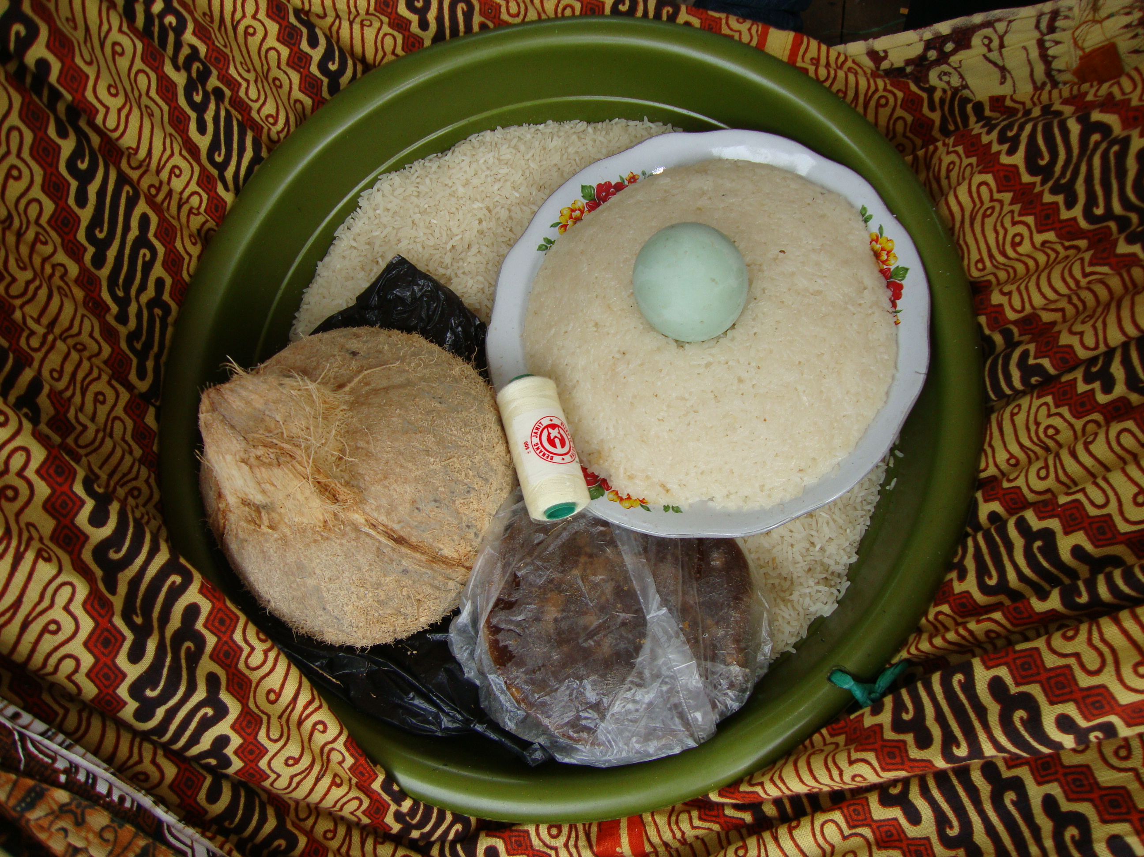
Picture 5. Piduduk
Source: Wajidi, 2014.
- Table Instrument
Table or graphic must be accompanied by a title. The title written in Times New Roman 11 pts. Table source information is written at the bottom of the table. The table only uses horizontal lines.

Example:
Table 1. Number of Industrial
and Labor Companies in Lampung

Years | Large industry
Years | Industry | Labors
1984 | 74 | 10.258
1985 | 74 | 10.258
1986 | 76 | 11.925

Source: Bappeda Tk.I Lampung, 1992.

D. CONCLUSION
(Albertus Extra Bold 10)
Conclusion must answer the problem(s) and purpose(s) of the study. Conclusion is not in the form of a summary and not a repetition of findings and discussion. Conclusion written in Times New Roman pts 11, single space. The first paragraph is aligned text left, straight with chapter’s title.
Next and following paragraphs uses special first line 1 cm format (1 tab).

ACKNOWLEDGMENT (Albertus Extra Bold 10)
Acknowledgment to the party or institution that helped the research. In this case, the names, workplaces and types of assistance are announced. Acknowledgments are not mandatory. Acknowledgment written in Times New Roman pts 11, single space. The first paragraph is aligned text left, straight with chapter’s title.
Next and following paragraphs uses special first line 1 cm format (1 tab).

REFERENCES
(Albertus Extra Bold 10)
The minimum number of source references is ten, consist of 80 percent primary sources (article journals, theses, dissertations and research report) and 20 percent of secondary sources. Author required to use the five most recent sources (in last ten years) except for classic references as historical data. The degree of novelty of the article referred to the proportion of the latest issue. Authors should ensure that every reference in the text appears in the list of references and vice versa. Wikipedia, personal blog, or non-scientific website is not allowed to be taken into account.
References written in Times New Roman pts 10. Referencing style is the American Psychological Association Style (APA), author can visit (http://www.apastyle.org) for seeing complete examples of the reference style. Authors are advised to use reference management programs such as Mendeley, Zotero, and EndNote.

formats for various types of references:

- Journal article: Author. (year). Title. Journal Name, volume (Issue), pages.
Example:
Bardis, Panos. (1979). Social Interaction and Social Processes. Social Science, 54 (3), 147-167.
Bhurga, Dinesh., dan Becker, Matthew. (2005). Migration, cultural bereavement and cultural identity. World Psychiatry, 4 (1), 18-24.
Burawoy, Michael. (1998). The Extende Case Method. Sosiological Theory. 16 (1), 4-33.

- Book: Author. (year). Book Title. City, State or Country: Publisher.
Example:
Barth. Fredrick. (2001). Kelompok Etnik dan Batasannya. Jakarta: UI Press.
Chatman, Seymour. (1980). Story and Discourse: Narrative Structure in Fiction and Film. United States of America: Cornell University.
Clark, Marshall. (2010). Maskulinitas: Culture, Gender, and Politics in Indonesia. Australia: Monash University.

- Part of book: Author. (year). Title. In Editor (Ed.), Book Title (pp. pages). City, State or Country: Publisher.
Example:
Chapman, Rowena. (2014). Penipu Ulung: Variasi Tema Laki-laki Baru. In Rowena Chapman dan Jonathan Rutherford (Ed.), Male Order: Menguak Maskulinitas (hlm. 151-165). Yogyakarta: Jalasutra.

Hatley, B. (2008). Postkolonialitas dan perempuan dalam sastra Indonesia modern. Dalam Foulcher, K. & Day, T. (Ed.), Sastra Indonesia modern kritik postkolonial (hlm. 226-259). (Toer, K.S. & Soesman, M., penerjemah). (Edisi revisi). Jakarta: Yayasan Obor Indonesia & KITLV-Jakarta. (karya asli pertama terbit tahun 2000).

- Conference proceedings: Author. (year). Title. In Editor (Ed.), Proceedings Title (pp. pages). City, State or Country: Publisher.
Example:
Sungkowati, Y .(2010). Persoalan lingkungan hidup dan urbanisasi dalam beberapa cerpen Indonesia. Proceedings Konferensi Internasional Kesusasteraan XXI HISKI Sastra dan Budaya Urban dalam Kajian Lintas Media, 78-90. Surabaya: Airlangga University Press.

- Newspaper article: Author. (year, Month, day). News Title. Newspaper Publisher, p. pages.
Example:
Abdalla, Ulil Abshar (2000, Agustus). Serat Centhini, Sinkretisme Islam dan Dunia Jawa. Kompas, hlm. 27.

- Web page/electronic sources: Author. (year). Title. Retrieved Month day, year, from URL.
Example:
Hardjasaputra, A. Sobana. (2011). Dinamika Kehidupan Sosial Ekonomi di Priangan 1870-1906, Retrieved 24 April 2012, from http://resources.unpad.ac.id.

- Unpublished paper: Author. (year). Title. In Event Title. City, State or Country.
Example:
Rahayu, Ruth Indiah. (2005). Militerisme Orde Baru dan Ideologi Koncowingking: Pengukuhan Ideologi Perempuan Indonesia Secara Pemaknaan Ksatria Jawa. Makalah dalam Konferensi Warisan Otoritarian di Indonesia, 1-15. Yogyakarta: Sanata Dharma.

- Thesis, dissertation: Author. (year). Title. Thesis University.
Example:
Budiman, Hary Ganjar. (2019). Tentara dalam Sinema; Konstruksi Maskulinitas Pasca Orde Baru. Thesis Fakultas Sastra Universitas Padjadjaran.

- Research Report: Author. (year). Research report: Title. City: Publisher.
Example:
Erwantoro, Heru., Nina Merlina, Risa Nopianti, Hary Ganjar Budiman. (2016). Research report: Sejarah Perkembangan Masyarakat Tugu di Jakarta Utara. Bandung: Balai Pelestarian Nilai Budaya Jawa Barat.

- Interview: Interviewee. (year, date). Interview type [email, phone, personal interview].
Example:
Kherustika, Zuraida (26 November 2012). Interview.

Notes that must be considered by the author:

- The editorial board accepts research articles with the theme of history and preservation of culture / cultural values in traditions, beliefs, arts, and films. These themes are related to the field of anthropology, art, literature, cultural studies, and history.
- The article has not been previously published, nor is it before another journal for consideration.
- Title, abstract and keywords must be written in two languages, Indonesian and English.
- The article is written in Indonesian or English. The length of the article is 16 pages of content (including pictures, tables, and reference). The article is typed using Microsoft Words (doc/docx) on A4 size paper, written in two column. The upper margin 4 cm, the lower margin 3 cm, 4 cm left margin and right margin 3 cm.
- All illustrations, figures, and tables are placed in the text, not placed at the end of the article.
- Citation and Reference are written according to APA style.
- Local terms that have not been registered with KBBI (such as ceremony, local game, song, etc) use lowercase letters and italics.
- Authors must attach ethical statement that can be uploaded into the journal page through the Supplementary Files Menu.
- Failure to comply with the author guidelines will result in rejection; resubmitting article is possible whenever guidelines have been sufficiently followed.
- Authors is expected to send the author profile to the editorial email (mail.patanjala@gmail.com). The contents of the profile consist of: name, place / date of birth, last education, position in the institution, three titles of research in the last 3 years. Profile is equipped with a photo in the form of a jpg file.

